How to register an app in active directory and provide RBAC to clients

1. Go to Azure Active Directory

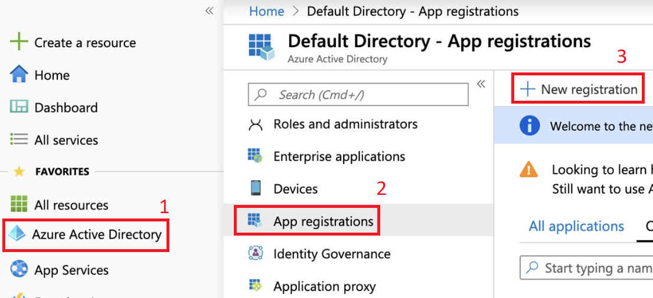

1. Register an app

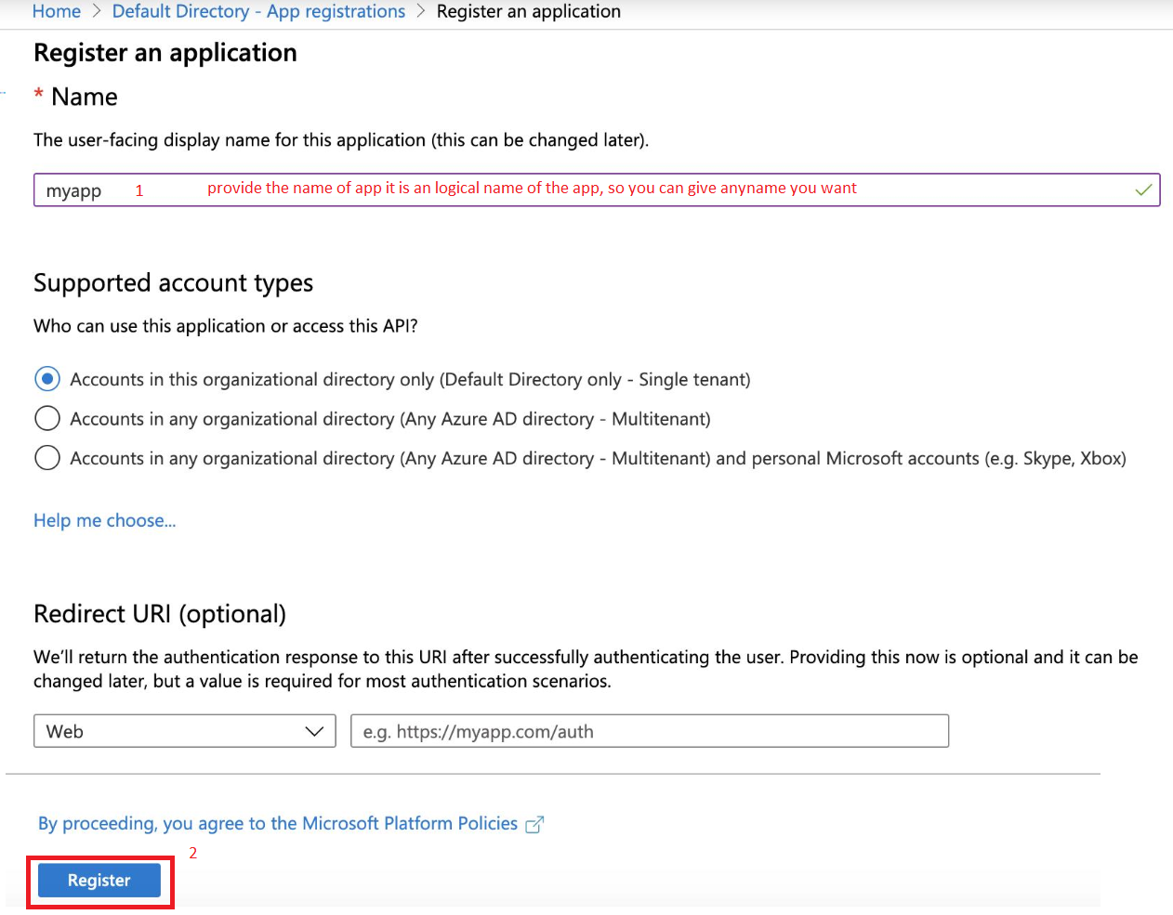

1. Once app is registered

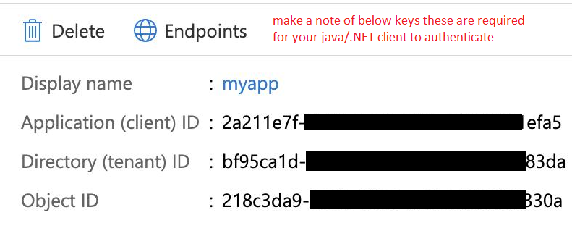

1. Now click on view API Permission button to add required permission
2. In API permission blade click on add a permission button
3. In “Request API permission button” in Microsoft APIs tab select Azure Batch for this example or you can add more as we need to access storage account as well so we add both Azure Batch and Storage account.

**Note: you can use this method for your other clients as well i.e. which is not related to Azure Batch or Storage account**

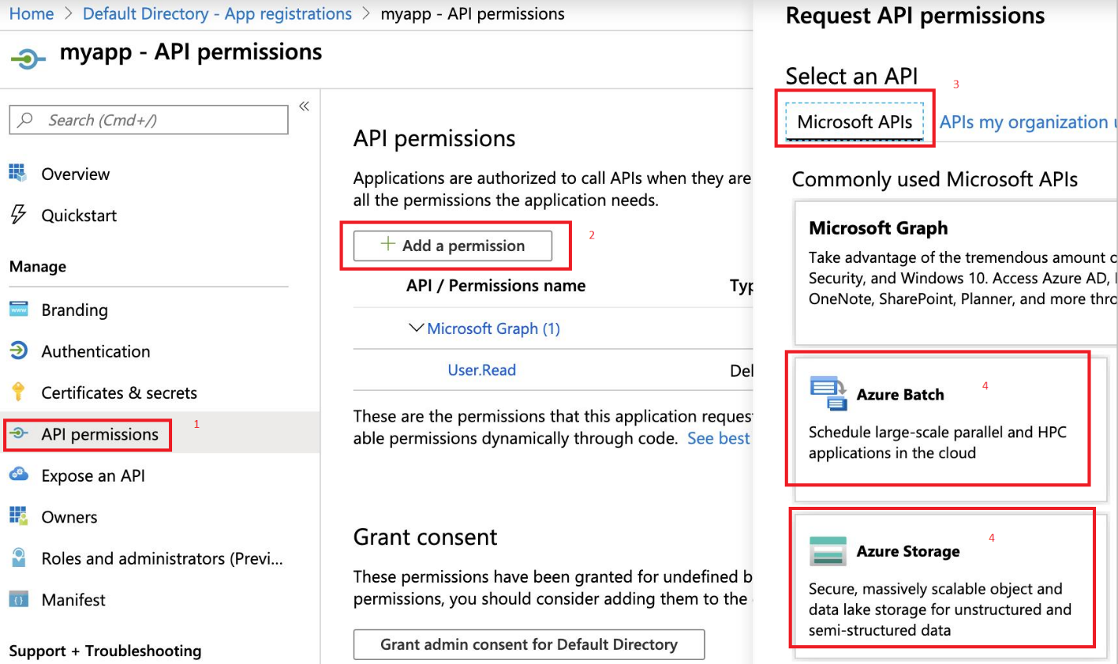

1. Click on Azure Batch a new blade will open select user_impersonation and then click on Add Permission button. Repeat this process for adding storage account as well.
2. Now click on “Grant admin consent for Default Directory” without this your changes will not work. And then click “Yes” in the pop p blade.
3. Once successful navigate to your resource group and then click on Access control (IAM) option for the resource group.
4. Click on the “+ Add” button

